IO3. CollaborArt Gamification App - Text for translation

Introduction

Welcome to CollaborArt Gamification App!

This art-based online digital gamification tool will help you to:
- learn how to identify social needs in your community
- creatively collaborate with your group to generate new ideas
- and develop innovative solutions to these needs

To do so, follow the 4 stages of the App:
- Identification of social needs
- Art as a social means
- Applied collective creativity
- Social Innovation in practice

Identification of social needs
Do you know what the people around you need? Are you aware of the needs of your neighbours, the families living in your neighbourhood or all the people in your community?

When we talk about “social needs”, we refer to problems of your society that can be addressed.

This part of the CollaborArt Gamification App wants to assist you at becoming more aware of the social needs in your environment. The first things that probably come into your mind are general topics like pollution, education, health and so on. But what does that mean in our day-to-day life?

What are the real-life problems out there around you and who is affected by these topics?

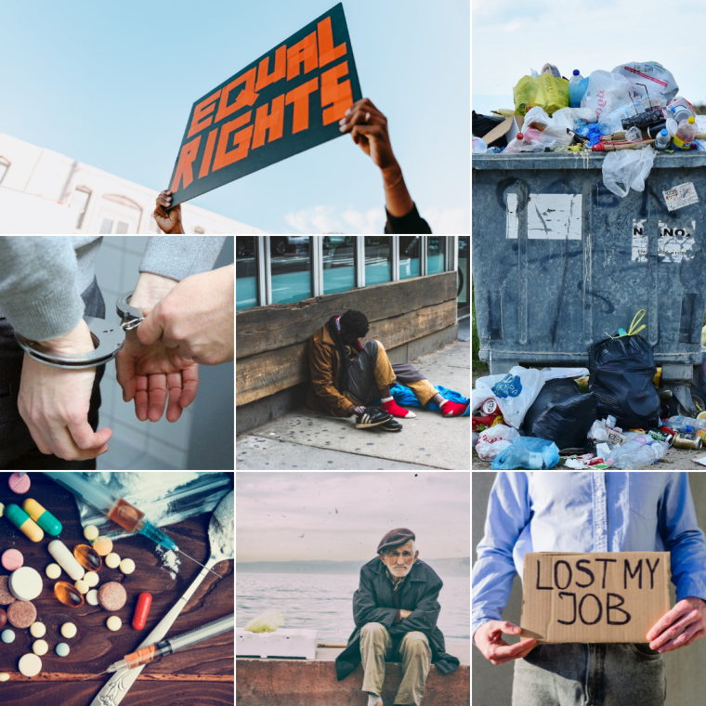
Unemployment
Unemployment tends to have negative psychological consequences, including the loss of identity and self-esteem, increased stress from family and social pressures, along with greater future uncertainty with respect to labour market status
Gender inequality
Gender inequality is the social phenomenon in which men and women are not treated equally. This issue involves very different experiences among men and women across many domains including education, life expectancy, personality, interests, family life, professional careers, access to rights and political affiliation.
Pollution
Pollution is a social issue because it is caused by human behaviours. Pollution has many negative impacts on the planet but also on people and society involving health, economic and social problems.
Drug abuse
Long-term substance abuse of legal and illegal substances causes millions of deaths and costs billions for medical care and substance abuse rehabilitation. The effects of drug abuse extend beyond users, spilling over into the larger society, imposing social and economic costs
Crime
Crime generally reduces safety, disrupts social order, creates chaos and confusion, hinders community collaboration and trust and creates serious economic cost to both the people and the society.
Poverty
Poverty is linked with several negative conditions such as substandard housing, homelessness, inadequate nutrition and food insecurity, unsafe neighbourhoods, inadequate childcare, lack of access to health care, education and work.
Social Isolation
Social isolation increases the risk of mental health issues and is associated with poor life satisfaction across domains, work-related stress, lower trust of institutions and business, and higher levels of use of substances.
Quiz
Although personal needs can be associated with social needs or problems, they are not the same. In order to raise your awareness of this, please try to distinguish between personal needs and social problems.

→ Which of these problems would you identify as a “social problem” more than a “personal need”?
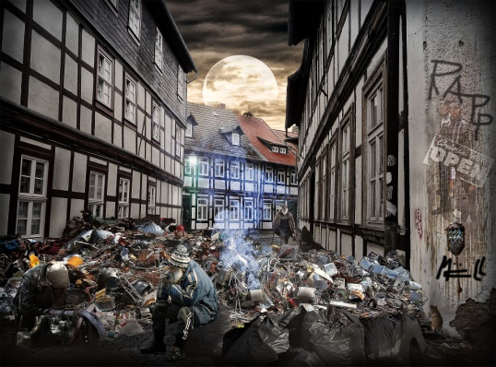

→ Which of these problems would you qualify more as “personal problems” than “social problems“?

Social problem | Personal need
Access to clean water | Fear
Drug abuse | Friendship
Bullying | Anger
Health care | Peer-group
Pollution | Need to belong
Crime | Acknowledgement
Gambling | Personal guidance
Bad infrastructure (transportation) | Family
Poverty | Spending social time
Racism | Sadness
Homelessness
Unemployment
Social Isolation
Access to education
Gender inequality

Activity
Go find evidence for social needs around the place where you are located. Your group should gather at least 3 images that illustrate these problems. Add the following information to these images:
- What is the social need?
- Who is affected by this?
- What is being done about this (by whom)?

Upload your evidences of social needs the App and discuss with the group
Additional resources
https://en.wikipedia.org/wiki/Social_issue
https://en.wikiversity.org/wiki/Social_problems
https://7esl.com/social-issues/

Art as a social means
Now it is time to get more familiar with ART. Maybe you are already aware of art and it’s multiple facettes but maybe this is new terrain for you. We want to help you open your eyes and ears and look around you: Where can you see and experience art and what do you think are the topics behind it?

Art addresses multiple purposes ever since. One of its primary reasons has been entertainment, of course. However, in the course of history art has also picked up cultural and political topics. It served as a means of expression, as a mirror to society or to its rulers.

Finally we want to make you aware that art can appear in many ways. Here are some examples:

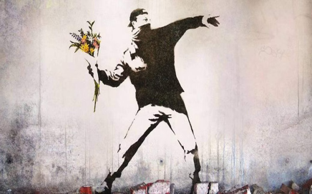

Quiz
Match the following examples with the corresponding type of art:

Visual art
Photos, Videos, Drawings, Posters, Graffiti
Haptic art
Sculptures, Installations
Written art
Books, Blogs, Lyrics
Auditive art
Music, Speeches, Sound installations
Enacted art
Theatre, Concerts
Activity
Find pieces of evidence of art in your near surroundings. Take a picture that shows this piece of evidence. The best way would be that each of the people in your team finds one thing and then you discuss which one is the example you actually want to share with the other groups.

For each evidence of art please answer the following questions:
- What was the intention of the artist?
- Which type of art is it?
- Why is this a good example for art?

Upload a picture of your evidence of art to the App and discuss with the group
Additional resources
https://www.youtube.com/watch?v=UPk56BR1Cmk
https://youtu.be/QZQyV9BB50E
https://www.npr.org/sections/health-shots/2020/01/11/795010044/feeling-artsy-heres-how-making-art-helps-your-brain?t=1644542901271
https://artsandculture.google.com/

Applied collective creativity
Finally, it is your team’s turn: Co-create something artsy. There are many ways to work collaboratively. Nowadays it is more important than ever before that we are able to also know how to work together in teams in a remote way.

There are so many ways in which collaboration can be done. Here are some examples for things that can be elaborated in teams (on- and offline):
- Slide-show – presentation: PowerPoint, Keynote, Prezi
https://www.artyfactory.com/art_appreciation/art-history-slideshows/art-history-slideshow.html
- Mind map
https://www.mindmapart.com/
- Collage
https://www.tate.org.uk/art/art-terms/c/collage
https://mymodernmet.com/collage-art-collage/
- Post-it collection
https://www.post-it.com/3M/en_US/post-it/
- Scribble board
https://scribbletogether.com/
https://miro.com/
- Online (shared) document
(e.g. Google Docs, MS Shared Documents, Dropbox, OpenOffice)
Quiz
Match the images with the description:
- Collage / Collection of images
- Slide-show - Presentation / Convey information visually
- Mind map / Order thoughts and ideas
- Scribble board / Write down all ideas
- Shared document / Digitally work on the same document

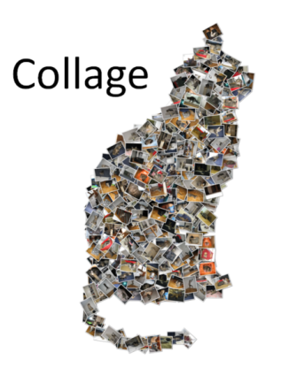
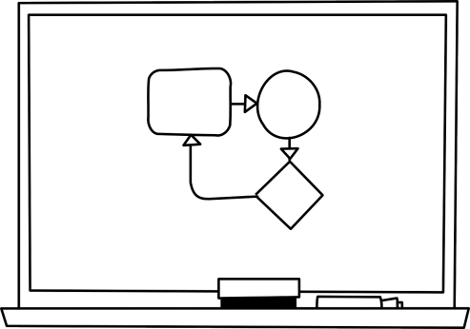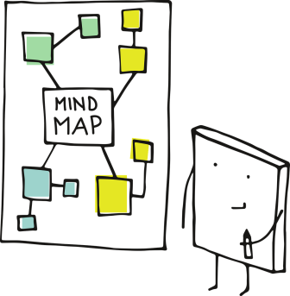

Activity
Use one of the previous examples (collage, slideshow, mind map, scrabble board, shared document) to create something creative that expresses the following things:
- Why is it important to collaborate?
- What are the obstacles and how to overcome them?
- Why is that especially relevant in a more and more digitalized world?

Upload a picture of your creation to the App and discuss with the group
Additional resources
https://youtu.be/ZqlTSCvP-Z0
www.miro.com
https://photo-collage.net/photo-collage-maker/

Social Innovation in practice
Social innovations are new ideas that meet social needs, create social relationships and form new collaborations. These innovations can be products, services or models addressing unmet needs more effectively

There are so many great solutions out there about social innovations that address and solve problems with the use of collective creativity and art. Here you have some examples:

Theatre plays that involve people with low literacy with the aim of enhance their education
https://novakdjokovicfoundation.org/using-drama-theater-classroom-promote-literacy/
https://centerfortotalhealth.org/using-theater-to-improve-childhood-literacy-and-lifelong-health/

Online games developed help children with cancer cope with the disease
https://hopelab.org/product/re-mission/

Collaborative colouring book created to highlight the plight of refugees and end family separation
https://www.familiesbelongtogether.org/coloring-without-borders/

Life-size glass sculpture drawing attention to the invisibility of people experiencing homelessness
https://www.lukejerram.com/invisible-homeless/

Quiz
Which of these Social Innovations exists already?

Exists | Does not exist
3D-printed houses | Flying house | https://www.3dsourced.com/guides/3d-printed-house-2/
Solar powered water checking device | Water as battery charger | https://www.helioz.org/en/wadi
A bubble barrier to clean rivers | Trash magnets for rivers | https://thegreatbubblebarrier.com/
Small scale plastic recycling machines | Small scale metal converters | https://plasticpreneur.com/
Food sharing platforms | Free food market | https://en.wikipedia.org/wiki/Foodsharing.de
App for kids to fight chronic pain | App for kids to learn about pain | https://ptcentral.org/treatment/pain-squad-intro/

Activity
What would you do about these problem topics?
- discrimination and racism
- (il)literacy and education
- pollution, climate and waste

Choose one out of these problems and come up with a creative solution for this problem! Your solution should contain these descriptions:
- Image that explains what you are suggesting (or underlines the problem)
- What resources are needed?
- What is the creative aspect in this?
- How could people be engaged in this activity?

Upload a picture of your innovative solution to the App and discuss with the group
Additional resources
https://youtu.be/1i7L6nOkQFo
https://www.socialinnovationacademy.eu/social-innovation-examples/
https://www.siceurope.eu/
https://www.weforum.org/agenda/2020/10/how-arts-and-culture-can-serve-as-a-force-for-social-change/
https://www.socialchallenges.eu/en-GB/community/4/challenges
https://civic-europe.eu/

